**EEC 521 Software Engineering**

**EMPLOYEE LOGIN PORTAL**

**DEVELOPERS GUIDE**

**Team Members**

* Sriniketh Venkatesh(2822307)
* Harsha Ganesh Samudrala(2834550)
* Shashank Reddy Kunta(2812308)

**Abstract**

This report includes a development presentation of an employee management system for managing employee data within a small company or organization. The system as such as it has been developed is called Employee Management System. It consists of functionally related API and database.

The choice of programming tools is Spring tool suite or we can use Eclipse IDE and we can integrate STS in eclipse. And we have used MySQL workbench to store the data.

**Keywords**

API, Database system, DBMS, table fields, primary key, foreign key, objects, classes, controls.

**Language specification: -**

Frontend:- HTML,CSS, AND JAVASCRIPT along with BOOTSTRAP

Backend:- JAVA

Database:-MySQL Workbench

**Technology used**:-The Spring framework comprises of many modules such as core, beans, context, expression language, AOP, Aspects, Instrumentation, JDBC, ORM, OXM, JMS, Transaction, Web, Servlet, Struts etc. These modules are grouped into Test, Core Container, AOP, Aspects, Instrumentation, Data Access / Integration, Web (MVC / Remoting) as displayed in the following diagram.

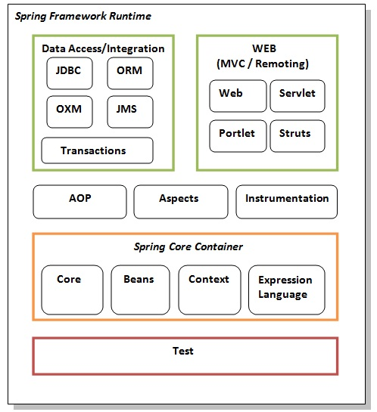

**POM.xml file**

**POM** is an acronym for **Project Object Model**. The pom.xml file contains information of project and configuration information for the maven to build the project such as dependencies, build directory, source directory, test source directory, plugin, goals etc.

This file contains the list of all the dependencies that are added to the application.

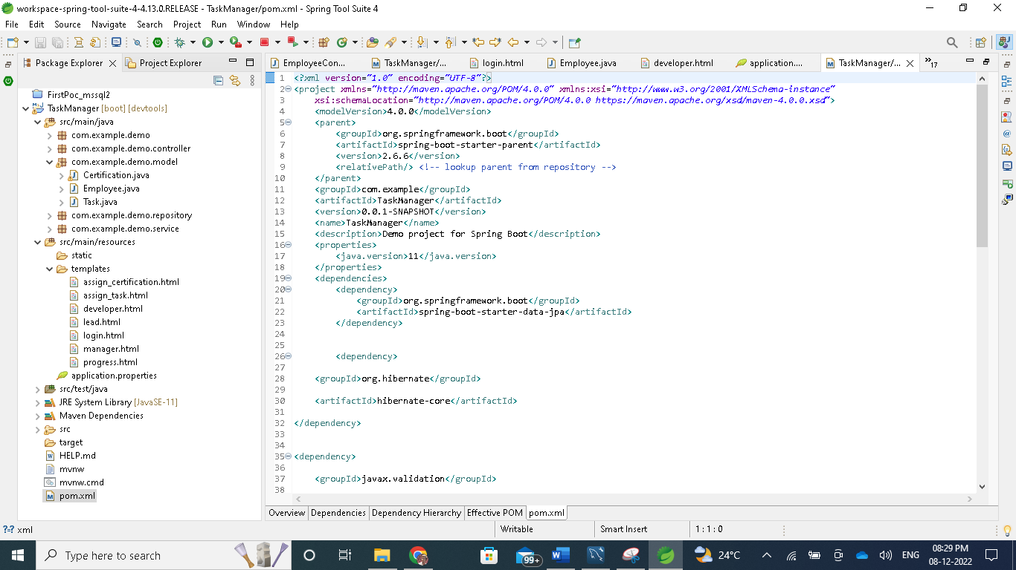

**Login Page**

For login page, we have used standard template. The empname and password will already be present in the data base. We just have to make sure to write the logic in the employeecontroller.java file as below.

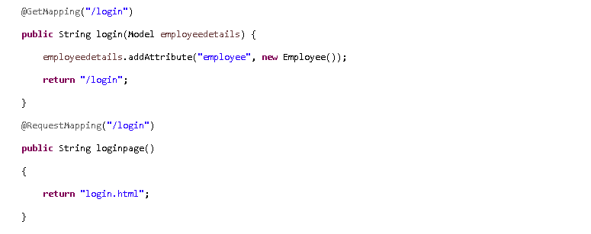

After entering the emp name and password, we have to check the roles that were in the database. Based on the role the page will get displayed.

If the credentials that are entering is matching to level 50 role in database, then the Developer page will get displayed.

If the credentials that are entering is matching to level 51 role in database, then the Lead page will get displayed

If the credentials that are entering is matching to level 52 role in the database, then the Manager page will get displayed

The below shows the front of the login page using the Thymeleaf template.

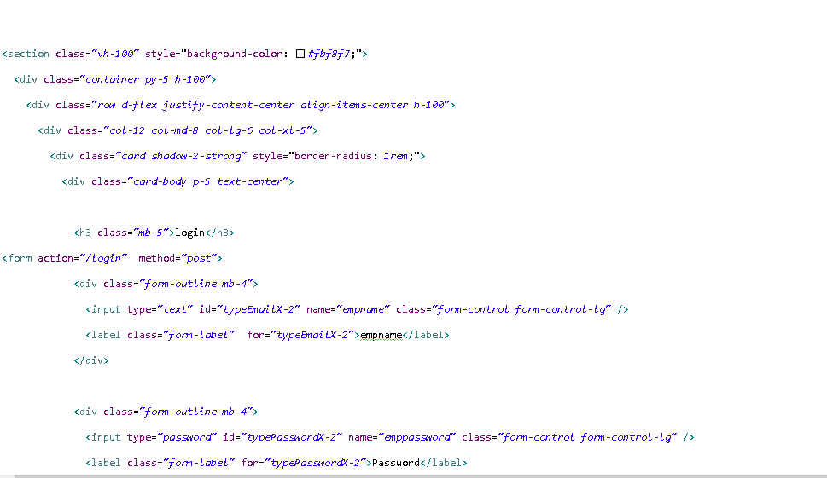

For this, we need to create the Database tables with Employee.Java

This creates the Employee table in the database. The administrator has to fill in the credentials manually.

Employee repository.java validates the credentials for role-based login.

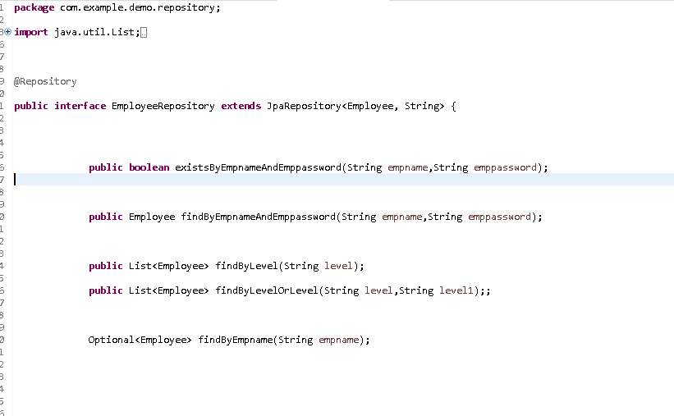

**Developer Page**

The moment when credentials that were entered match Level 50, The developer page will get opened. The task and employee details will be shown on this page. In Task Manager, the roles are divided into 3 levels. Level 50 stands for Developer. When a developer login with the credentials, the page has two tabs(employee details and assigned task) will be shown. The employee details tab consists of the developer employee Id and level. The assigned task tab consists of the list of all the tasks that were assigned by the respective manager.

The assigned task tab consists of the tasks that were assigned by the respective manager along with the task description. The below shows how the tasks in the database is stored.

To store the tasks we have to create the task table using task.java.

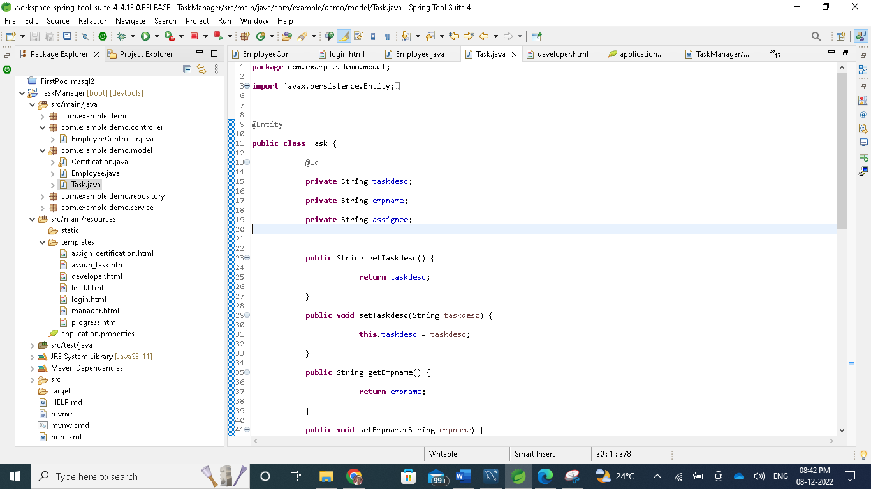

Task. repository file can have multiple interfaces that fetch the task to the respective employee id.

Spring uses Hibernate ORM to map the database.The flow will be as follows

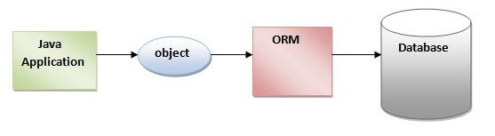

Hibernate is a Java framework that simplifies the development of Java applications to interact with the database. It is an open-source, lightweight, ORM (Object Relational Mapping) tool. Hibernate implements the specifications of JPA (Java Persistence API) for data persistence. The ORM tool internally uses the JDBC API to interact with the database.Java Persistence API (JPA) is a Java specification that provides certain functionality and standard to ORM tools. The **javax.persistence** package contains the JPA classes and interfaces. For this task manager project, we have used both these things to avoid using JDBC separately.

**Lead Page**

The moment when credentials that were entered matches to Level 51, The lead page will get opened. The task and employee details will be shown in this page.When a lead login with the credentials, the page having three tabs(employee details ,assigned task and developers list) will be shown. Employee details tab consist of lead employee Id and level. Assigned task tab consists of the list of all the tasks that were assigned by the respective manager. Developers tab consists the list of all the developers in the company

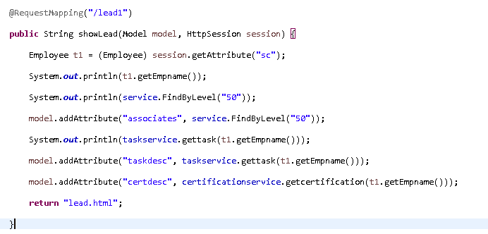

The assigned task tab consists of the tasks that were assigned by the respective manager along with the task description.Developers tab consists of the list of all the developers who are there in the company. This list automatically updates the data in database whenever there is a new developer joined in the company. For this Employee service .java is used. This service layer file consists of the logic that is required to fetch the data for different functions is written here.

**Manager page**

The moment when credentials that were entered matches to Level 52, The manager page will get opened.When a manager login with the credentials, the page having fourtabs(employee details ,assign task, developers list and lead list) will be shown. Employee details tab consist of lead employee Id and level. Assign task tab consists the link to assign the tasks to the developers and leads. Developers tab consists the list of all the developers in the company. Leads tab consists the list of all the leads in the company. If there is any mistake in employee details, please contact the administrator to change the details.

The manager has an additional role to assign the task to all the associates.Assign task tab consists the link to assign the tasks to the developers and leads.. As a manager , you can assign tasks to leads and developers in the company. A manager can see the list of all the tasks that were assigned by them.

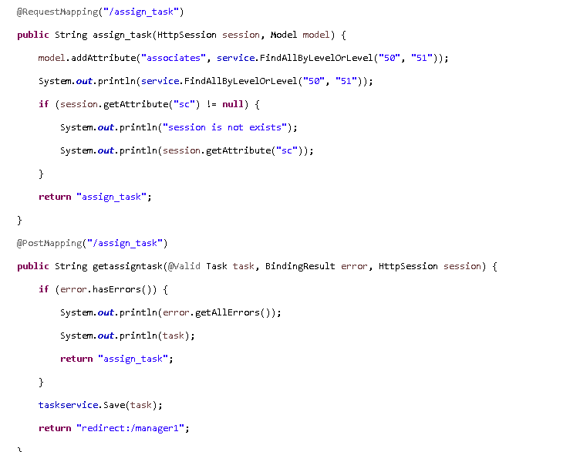

**APPENDIX**

**API-** Application Programming Interface

**ORM**-Object Relational Mapping